Ideation Phase

Brainstorm & Idea Prioritization

Date | 24-06-2025
Team ID | LTVIP2025TMID48302
Project Name | ToyCraft tales: tableau's vision into toy manufacturer data
Maximum Marks | 4 Marks

Step-1: Team Gathering, Collaboration and Select the Problem Statement

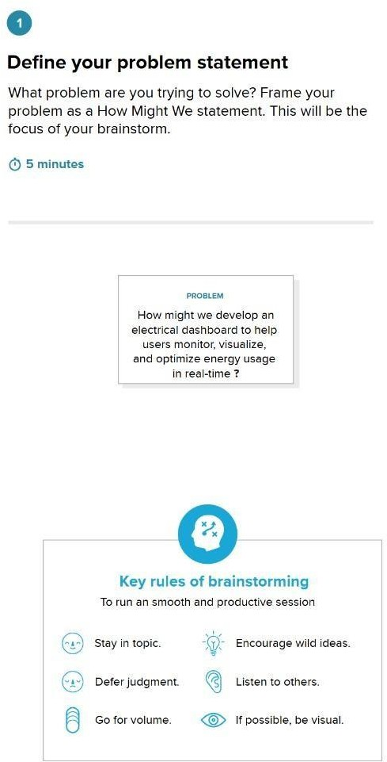

Step-2: Brainstorm, Idea Listing and Grouping
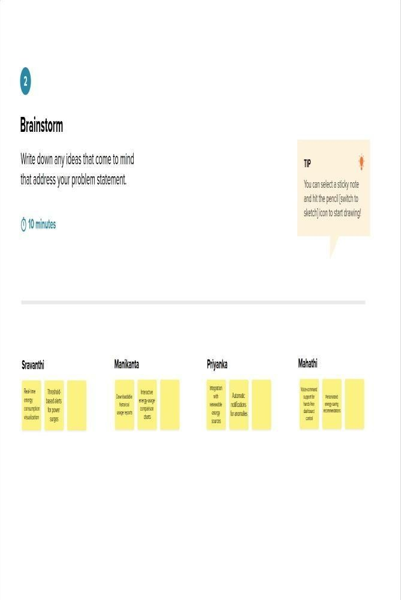
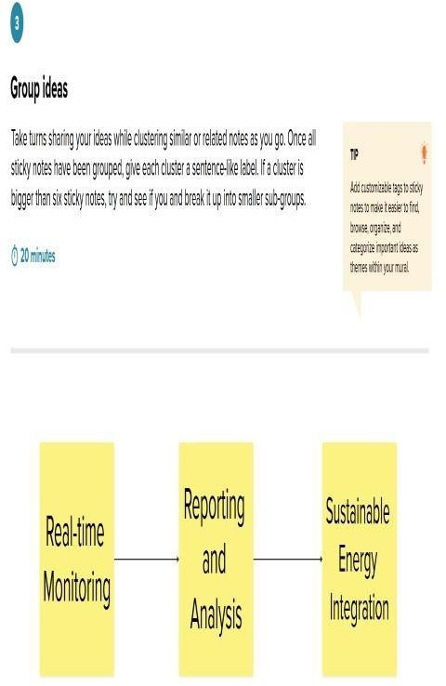
Step-3: Idea Prioritization

